**Assignment 2 – CSC/DCS 265/465 – Spring 2017 – Due March 7**

**Fengyi, Zhao 29352739**

**Q1. The picture includes question 1, 2, 3(a)(b)(c).**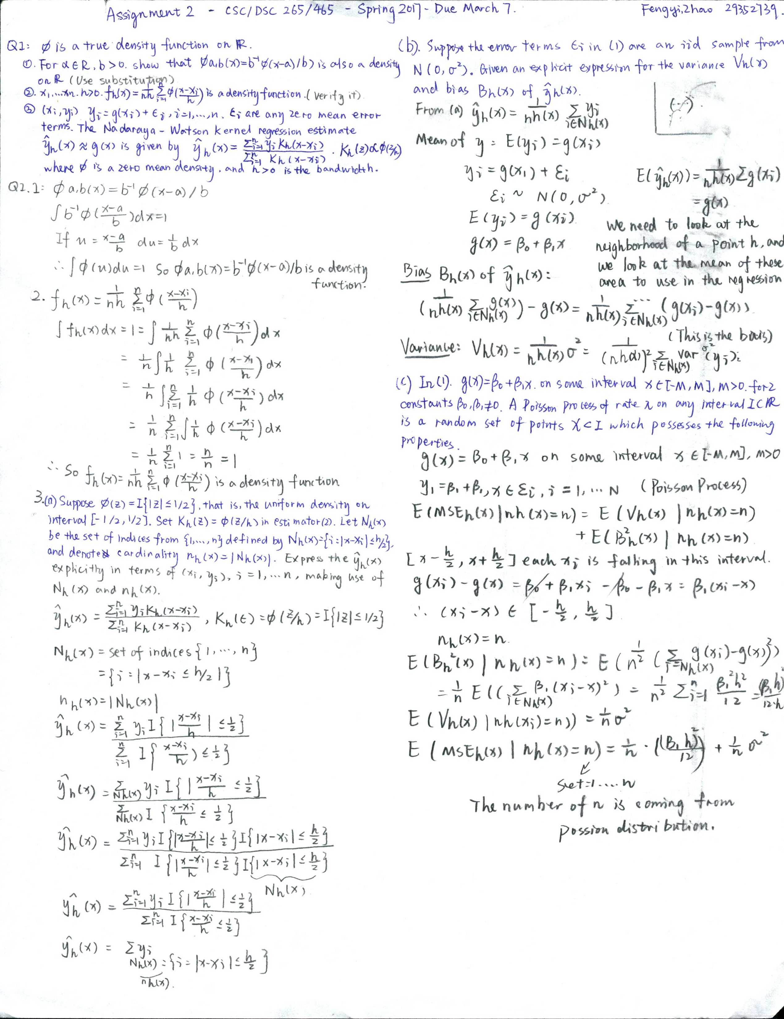

**Q1: 3(d) Coding in R-Studio**

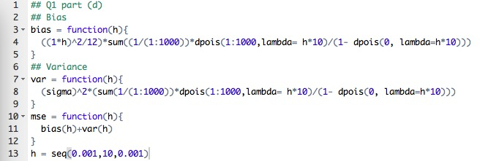

**Q2**

**Part (a) and (b)**

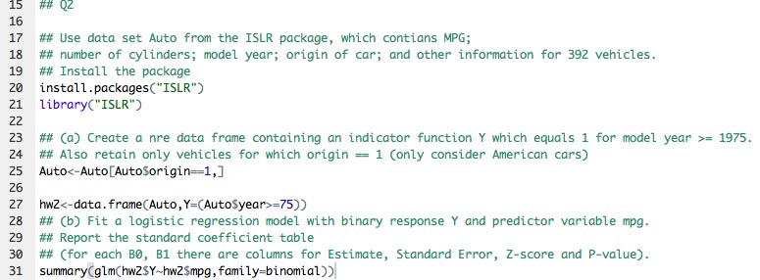

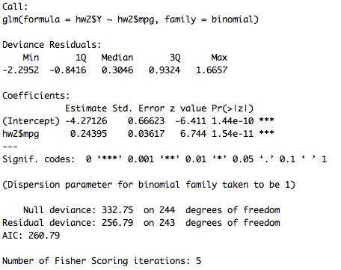

**Part (c) Create a graph**

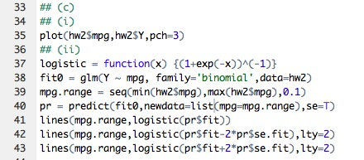

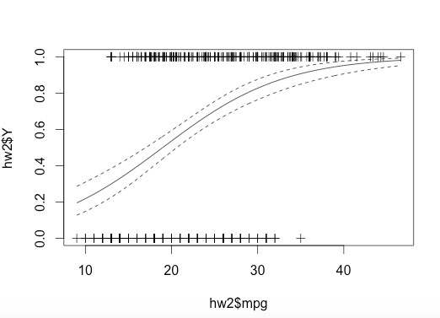

**Part (d) Construct side-by-side boxplots of mpg for each of the six combinations of Y and cylinders. Examining the boxplot, would mpg = 20 be strong evidence that the model year was >= 1975 for a 4 cylinder vehicle? What about an 8 cylinder vehicle?**



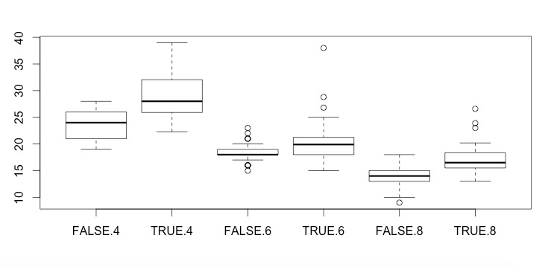

**Part (e)**



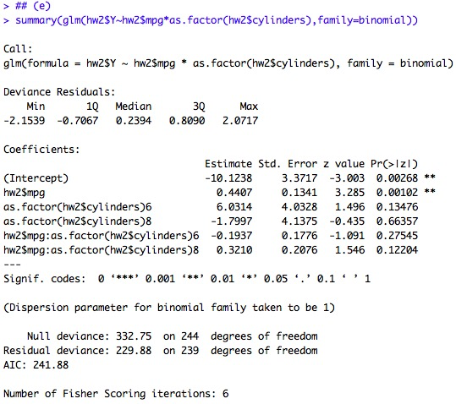

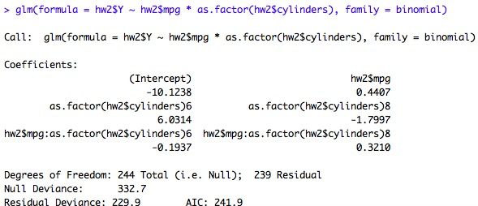

**Part (f)**

**(See code and run code for graph)**

**Q3**

**Part (a)**



**(There are more code)**

**Part (b) and Part (c)**

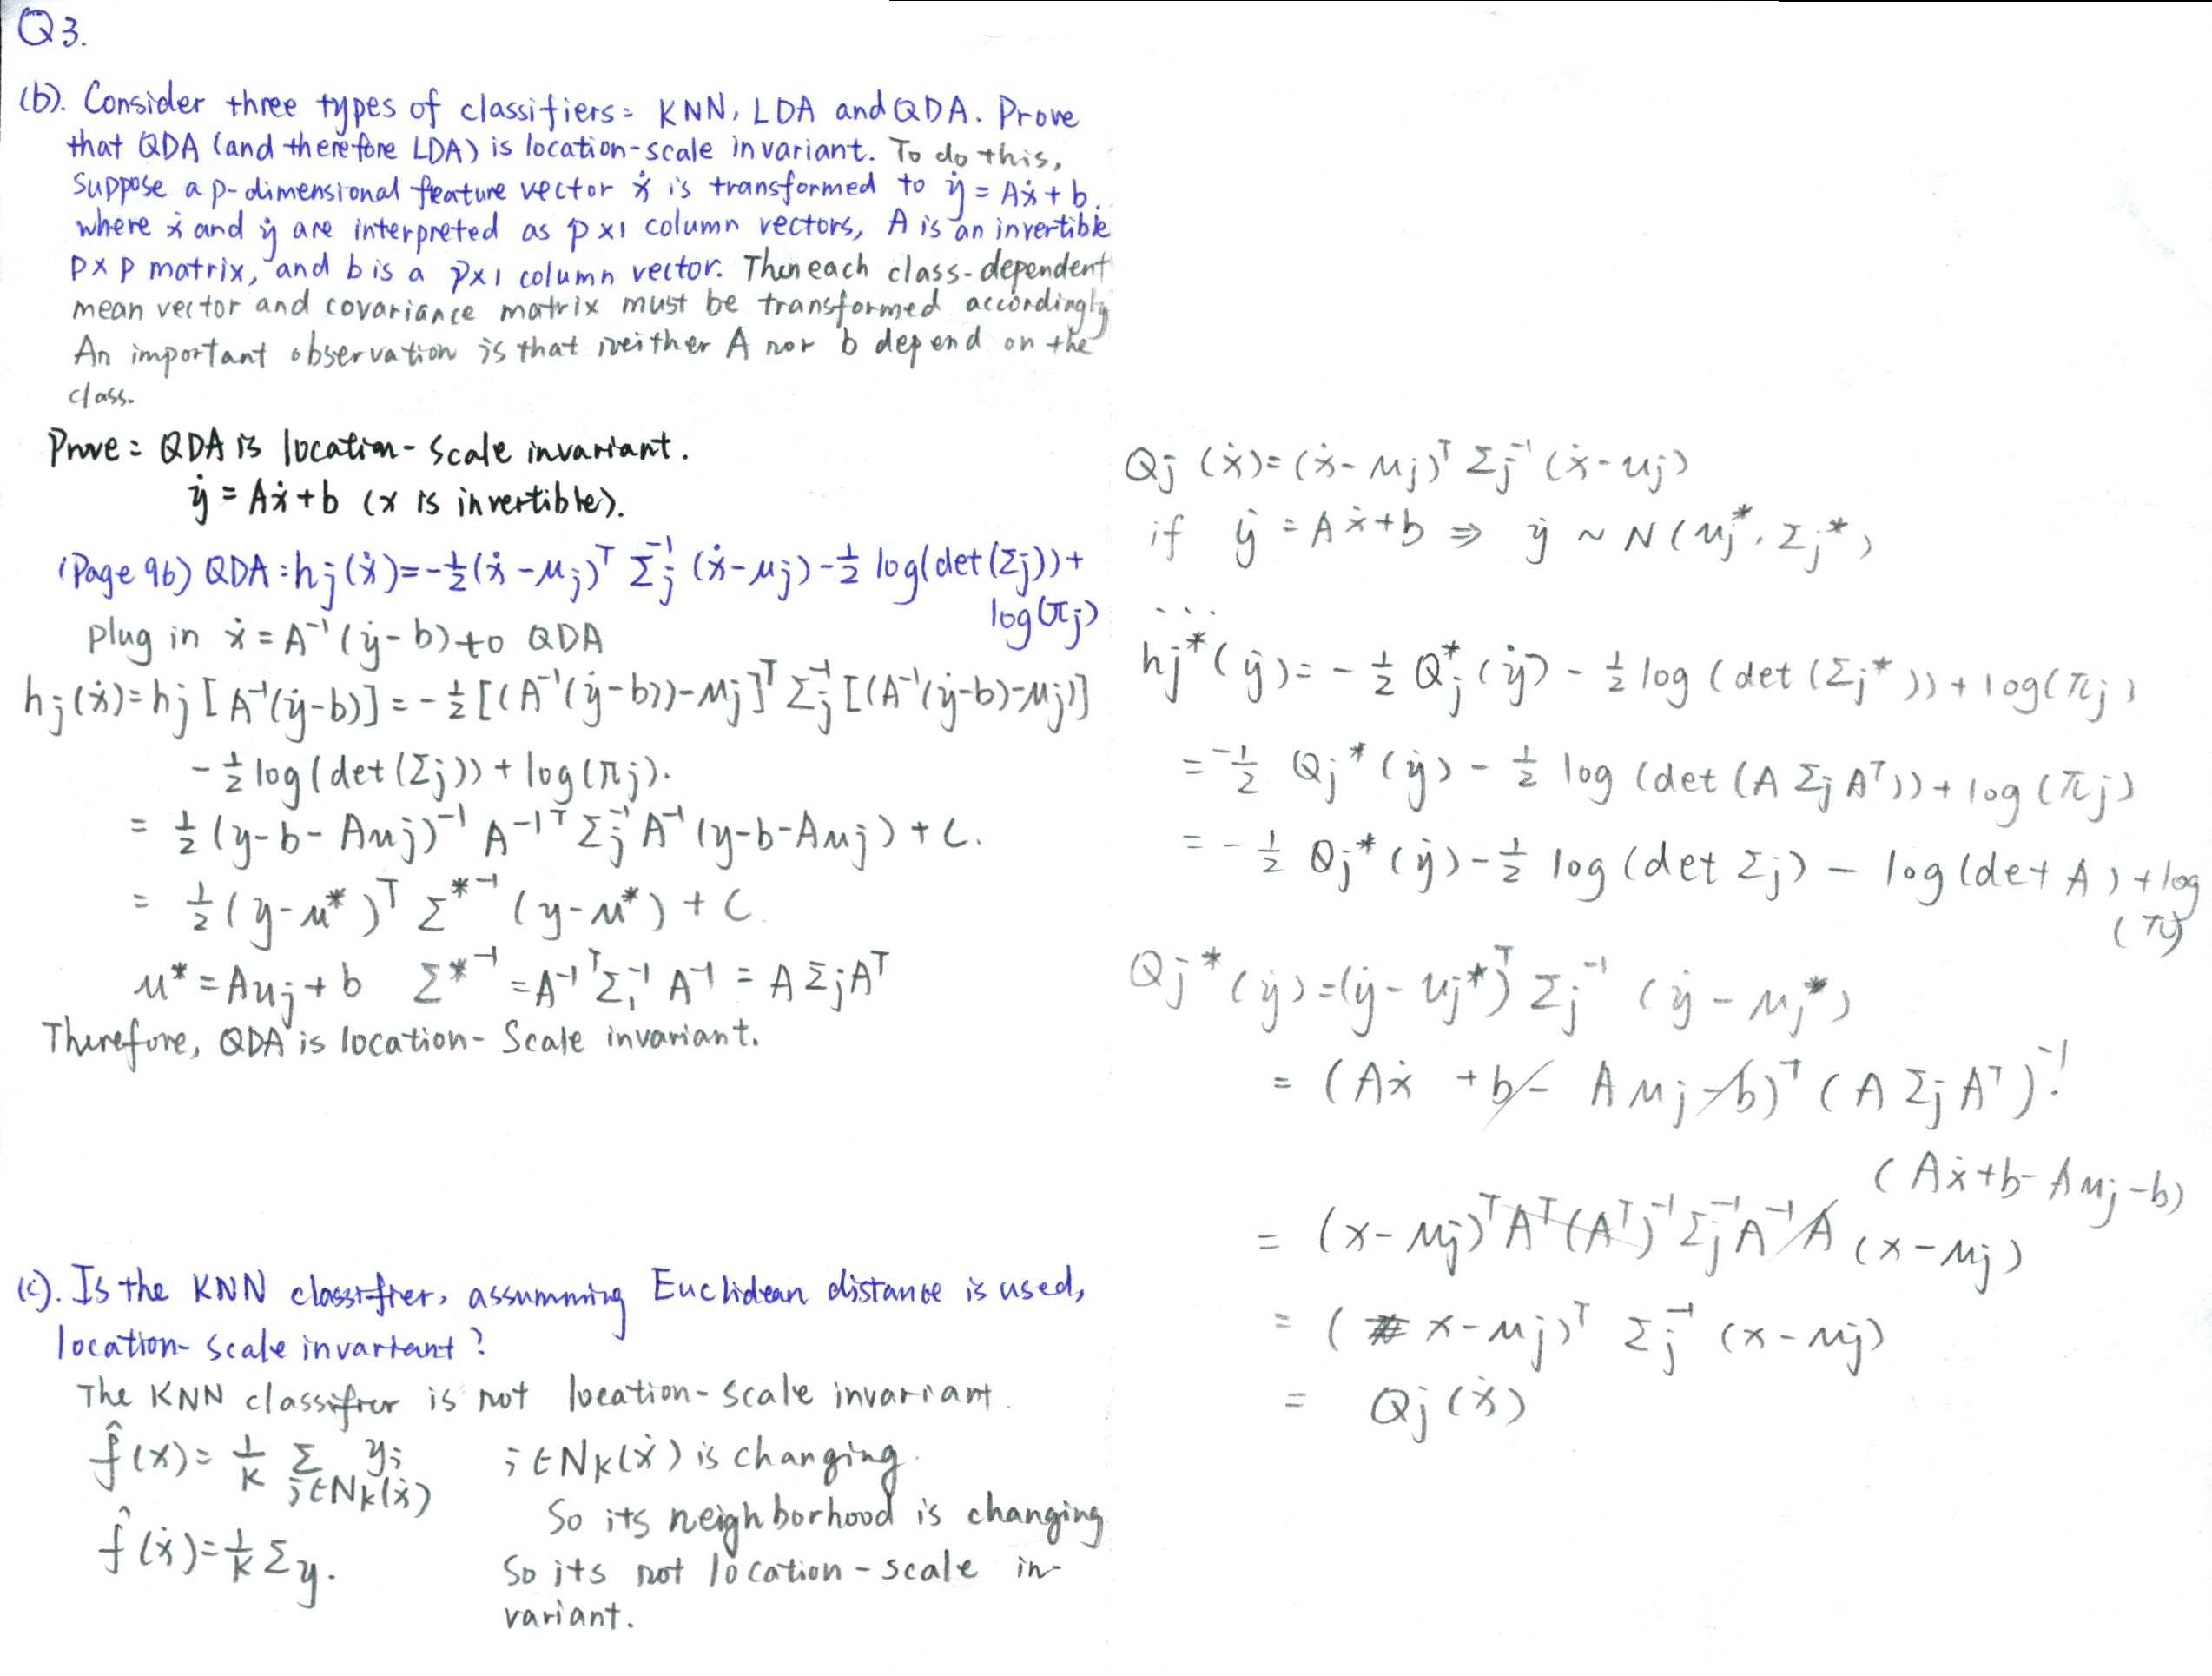

**part (d)**

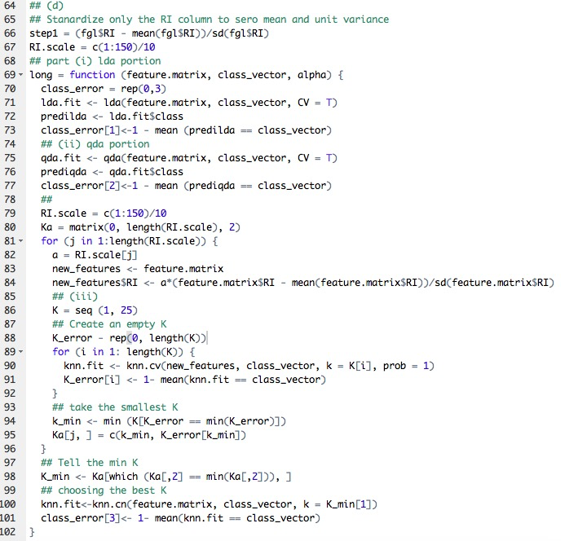

**Part (e)**

**Part (f)**

**Part (g)**

**(See Code)**